**CSE3011 NETWORK PROGRAMMING**

**LAB EXPERIMENT 2**

NAME – B PRATYUSH

REGISTRATION NUMBER – 19BCN7114

LAB SLOT – L11+L12

FACULTY – PROF. MUNEESWARI

Experiment Description: Client Server Communication using Sockets

**Client End:**

**MyClient.java**

**Code:**

import java.net.*;

import java.io.*;

class MyClient{

public static void main(String args[])throws Exception{

Socket soc=new Socket("localhost",3333);

DataInputStream din=new DataInputStream(soc.getInputStream());

DataOutputStream dout=new DataOutputStream(soc.getOutputStream());

BufferedReader br=new BufferedReader(new InputStreamReader(System.in));

String str="",str2="";

while(!str.equals("stop")){

str=br.readLine();

dout.writeUTF(str);

dout.flush();

str2=din.readUTF();

System.out.println("Server says: "+str2);

}

dout.close();

soc.close();

}

}

**Server End:**

**MyServer.java**

**Code:**

import java.net.*;

import java.io.*;

class MyServer{

public static void main(String args[])throws Exception{

ServerSocket ss=new ServerSocket(3333);

Socket soc=ss.accept();

DataInputStream din=new DataInputStream(soc.getInputStream());

DataOutputStream dout=new DataOutputStream(soc.getOutputStream());

BufferedReader br=new BufferedReader(new InputStreamReader(System.in));

String str="",str2="";

while(!str.equals("stop")){

str=din.readUTF();

System.out.println("client says: "+str);

str2=br.readLine();

dout.writeUTF(str2);

dout.flush();

}

din.close();

soc.close();

ss.close();

}

}

**Server End Output:**

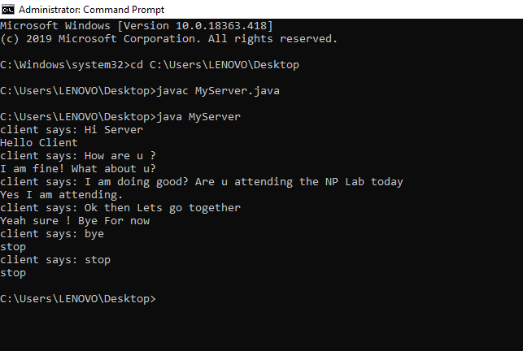

**Client End Output:**

